Security best practices for your VPC:-

Complete the following tasks to prepare to create and connect your VPCs. When you are finished, you will be ready to deploy your application on AWS.
Tasks: Plan your VPC
- Sign up for an AWS account
- Verify permissions
- Determine your IP address ranges
- Select your Availability Zones
- Plan your internet connectivity
- Create your VPC
- Deploy your application
Notes- There are mention points, As per standard guidelines of AWS Documentation of Security best practices Guidelines:
- Network Design & Segmentation
When you add subnets to your VPC to host your application, create them in multiple Availability Zones. An Availability Zone is one or more discrete data centers with redundant power, networking, and connectivity in an AWS Region.
- Using multiple Availability Zones makes your production applications highly available, fault tolerant, and scalable.

- Security Groups & Network ACLs
- Use security groups to control traffic to EC2 instances in your subnets.
- Use network ACLs to control inbound and outbound traffic at the subnet level. Use Secuirty groups & Nacls Avoid using 0.0.0.0/0 in inbound rules unless absolutely necessary.
- Periodically review unused or overly permissive rules with AWS Config or Security Hub.Control subnet traffic with network access control lists.

- Identity & Access Management (IAM)
Manage access to AWS resources in your VPC using AWS Identity and Access Management (IAM) identity federation, users, and roles.
- Use IAM roles instead of long-term access keys for EC2 instances or applications.
- Enable IAM Access Analyzer to identify resources shared with external accounts.
- Enforce MFA (Multi-Factor Authentication) for all IAM users.
- Apply least-privilege policies — grant only what’s necessary.
- Use service control policies (SCPs) in AWS Organizations to prevent risky actions at account level.

- Monitoring and logging
- Use VPC Flow Logs to monitor the IP traffic going to and from a VPC, subnet, or network interface.
- Enable VPC Flow Logs for all subnets and interfaces — send logs to CloudWatch orCloudTrail or S3 for analysis
- Use Network Access Analyzer to identify unintended network access to resources in our VPCs.
- Use AWS Network Firewall to monitor and protect your VPC by filtering inbound and outbound traffic.
- Use Amazon GuardDuty to detect potential threats to your accounts, containers, workloads, and data within your AWS environment. The foundational threat detection includes monitoring the VPC flow logs associated with your Amazon EC2 instances.

Advanced Network Security Services
- Deploy AWS Network Firewall for centralized inspection and filtering across subnets.
- Use AWS WAF and AWS Shield Advanced to protect web-facing applications from DDoS and Layer 7 attacks.
- Leverage Route 53 Resolver DNS Firewall to block domain queries to malicious or unwanted hosts.
- Use AWS Network Access Analyzer to continuously validate your intended network access paths.
Src.Reference :- https://docs.aws.amazon.com/vpc/latest/userguide/vpc-security-best-practices.html

2. OS Hardening
OS hardening means securing the operating system by reducing its attack surface – disabling unnecessary services, enforcing least privileges, applying patches, and configuring strong authentication.
In AWS, you combine OS hardening with cloud-level security like IAM, VPC, Security Groups, and AWS Systems Manager.

OS Hardening in AWS
Category | Description | AWS Tools/Best Practice
Access Control | Use IAM roles for EC2 instances (no hardcoded credentials). | IAM Roles, Instance Profiles
Network Security | Limit inbound/outbound traffic. | Security Groups, NACLs
Logging & Monitoring | Enable logging for OS & AWS activities. | CloudWatch Logs, AWS Config, GuardDuty
Patch Management | Regularly apply security updates. | AWS Systems Manager - Patch Manager
Encryption | Use encrypted EBS volumes and TLS. | EBS Encryption, ACM Certificates
Backup | Automate snapshots and AMIs. | AWS Backup, Lifecycle Manager
Compliance Templates | Use CIS/AWS Hardening Benchmarks. | AWS Inspector, Security Hub
- Windows Server Hardening (AWS EC2)
  - Update and Patch
- Enabling Window Update which automates the updates via AWS System Manager Patch Manager
  - Account & Access Control
- Disable the Default Administrator Login & Create least-privileges users and apply Group Policy
- Enforce password complexity and expiration:
  - Run secpol.msc - Account Policies - Password Policy.
  - Enable User Account Control (UAC).
  - Remote Desktop (RDP) Security
- Restrict RDP in AWS Security Group (only from your IP)
- Change default RDP port (3389 - custom port) if possible
- Use Network Level Authentication (NLA)
  - Windows Firewall
netsh advfirewall set allprofiles state on
netsh advfirewall firewall add rule name="Allow RDP" protocol=TCP dir=in localport=3389 action=allow

  - Remove Unnecessary Roles and Features
- Server Manager → Remove Roles/Features not needed (e.g., IIS if unused).
  - Logging and Auditing
- Enable Windows Event Logs (Security, System, Application).
- Forward logs to CloudWatch Logs Agent.
  - Antivirus and Malware Protection
- Install Microsoft Defender or integrate AWS GuardDuty + Inspector.
  - . BitLocker Encryption
- Use BitLocker for C:\ drive encryption.
- Store keys in AWS KMS or SSM Parameter Store.
  - Disable SMBv1
- Set-SmbServerConfiguration -EnableSMB1Protocol $false
- AWS-Specific
- Enable EC2 Launch Agent for automatic password rotation.
- Use AWS Inspector to check compliance with CIS Benchmark for Windows.

Unutnu Hardening important notes:
Ec2 click on Launch Instance
- Avoid using defult passwords instead of this Use strong & Unique key passwords login
  - Password Complexity
  - Password Rotation
  - Password Double checks
- Enable Two or Multi-factor Authentication for all users
  - IAM roles
  - MFA for users
  - Principles of Least Privileges
- Update and patch Regularly
  - Update os
    - Disable root logiN
    - Use SSH keys
    - Enable auto-updates
  - Create AMI Backups
  - Schedule Automated Patching (no manual patching)
  - Automation
  - Instance reboot
  - Testing
  - Rollback Plan
  - Monitor & verify
  - Compliance and Reporting
  - Third-party software
  - Documentation

- Implement Network Security
  - Private subnet
  - Nat Gateways
  - Security Groups
  - Network Access Control list
  - Harden VPC endpoints
  - WAF
- Use Encryption / Data Protection
  - EBS Encryption
- S3 encryption (AES-256 or KMS)
- Backup using AWS Backup
- Monitor & Audit to detects and respond to security incidents activity & logs.
  - Cloud watch
  - Cloud Trail
  - Guard Duty enabled
  - AWS SNS for alerts

Harden Ubuntu (Production-Level)
Update System and Lock Down Access
sudo apt update && sudo apt upgrade -y
sudo apt install unattended-upgrades
sudo passwd -l root
sudo nano /etc/ssh/sshd_config
# PermitRootLogin no
# PasswordAuthentication no
sudo systemctl restart ssh

- Ubuntu 22.04, x86_64 or Ubuntu 20.04 / 22.04 / 24.04 on ASecurity Baselines including

Launch Instance
After launching EC2 Ubuntu Server and connect it using SSH
To check whether pro is activated or not run command:
Sudo pro status –wait
Check Usd if disabe then do it enable
#sudo apt install usg –y
Then
Sudo usg fix <cis_servername>
Then usd will start auditing
Clean the Image
#sudo cloud-init clean –machine-id
Now go back to the console
Click on action nd create Imag eand templates
Caret image name
Now cjevk on AMIs
Now launch instance

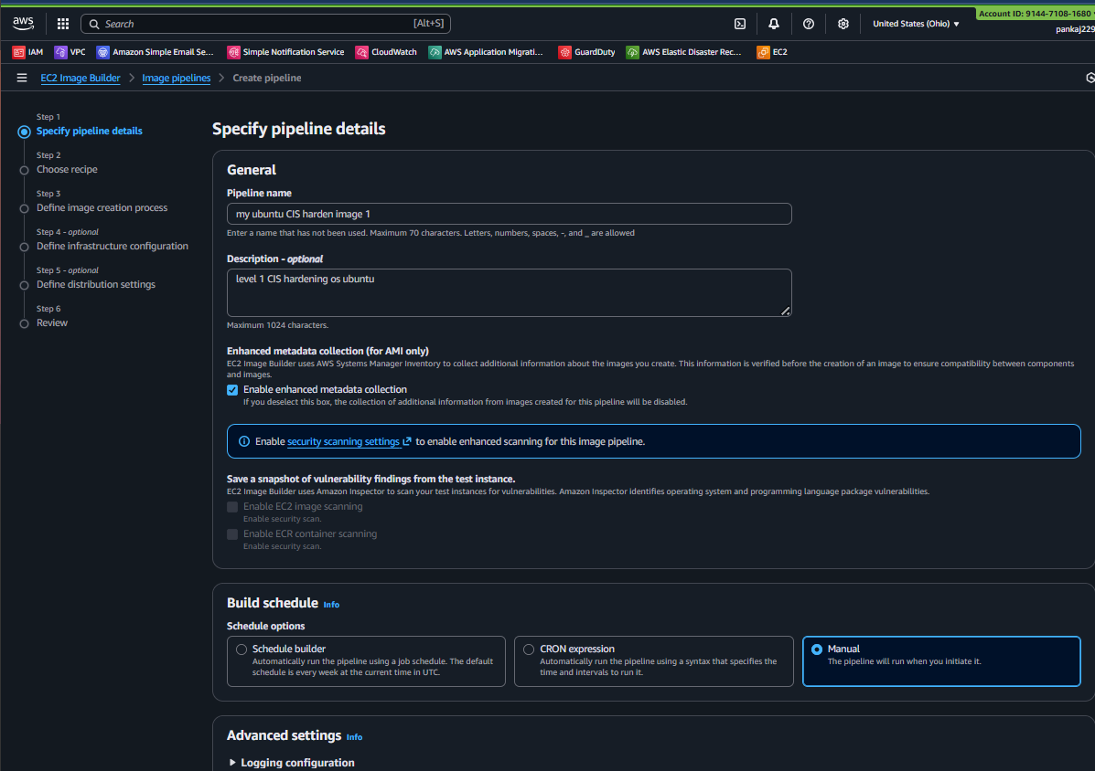
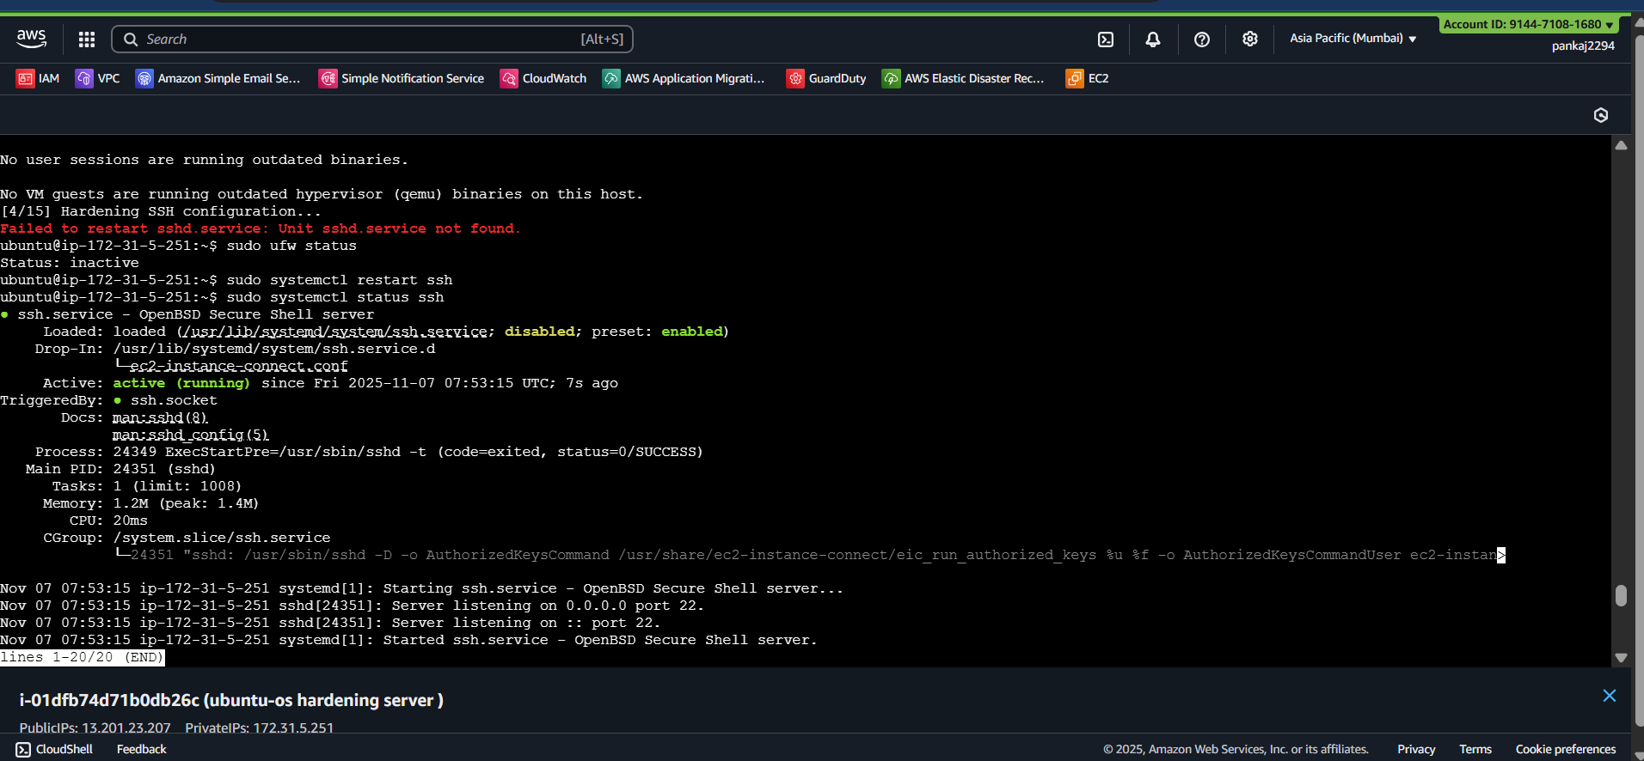
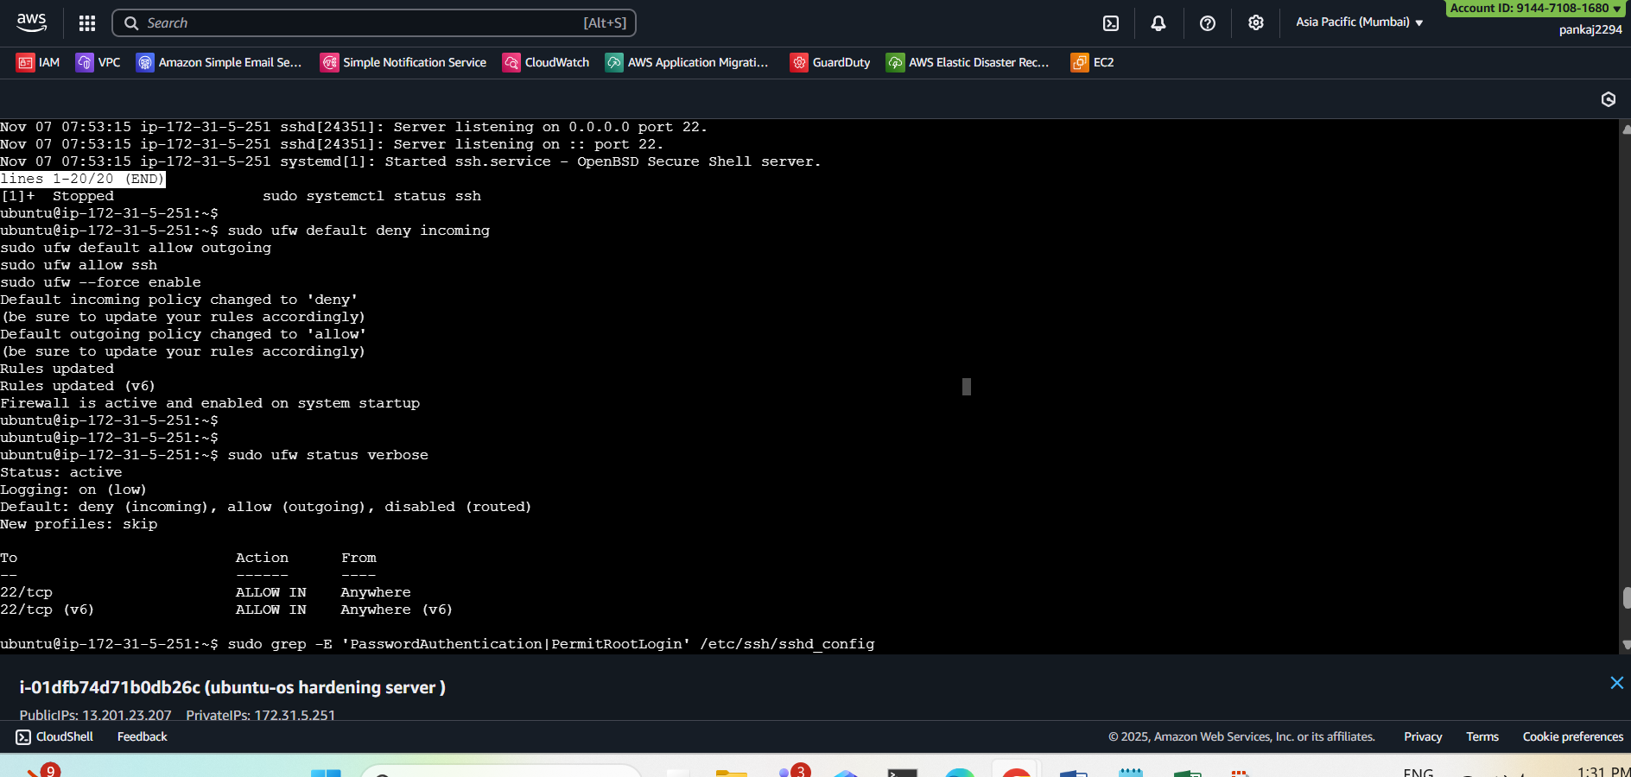
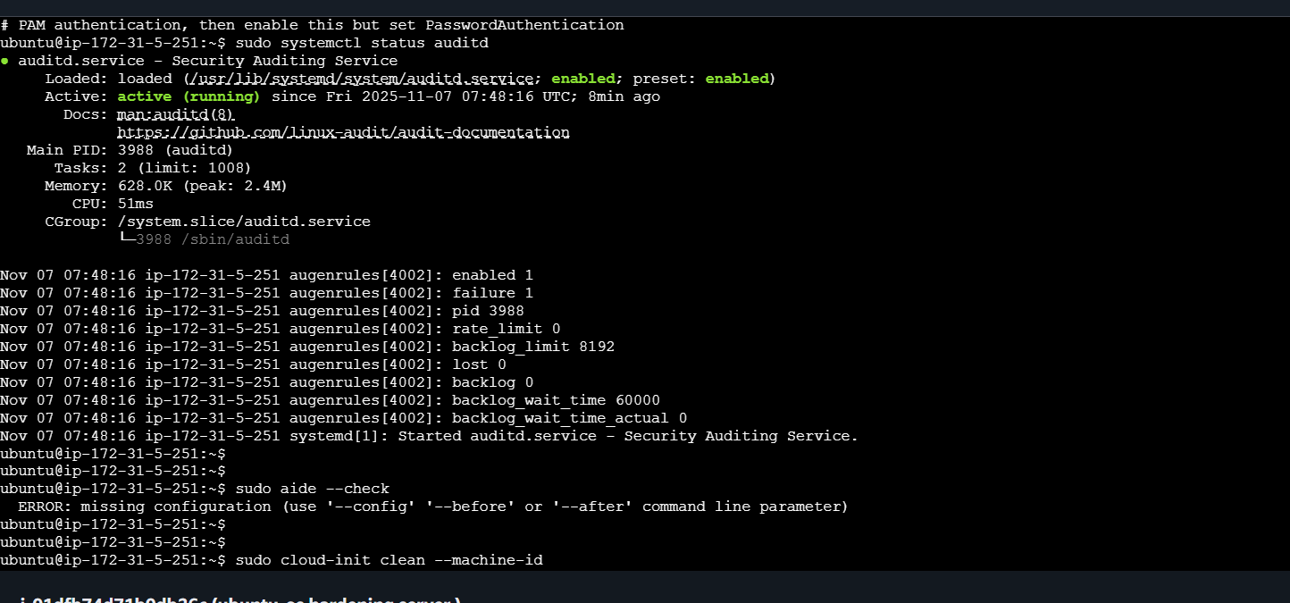
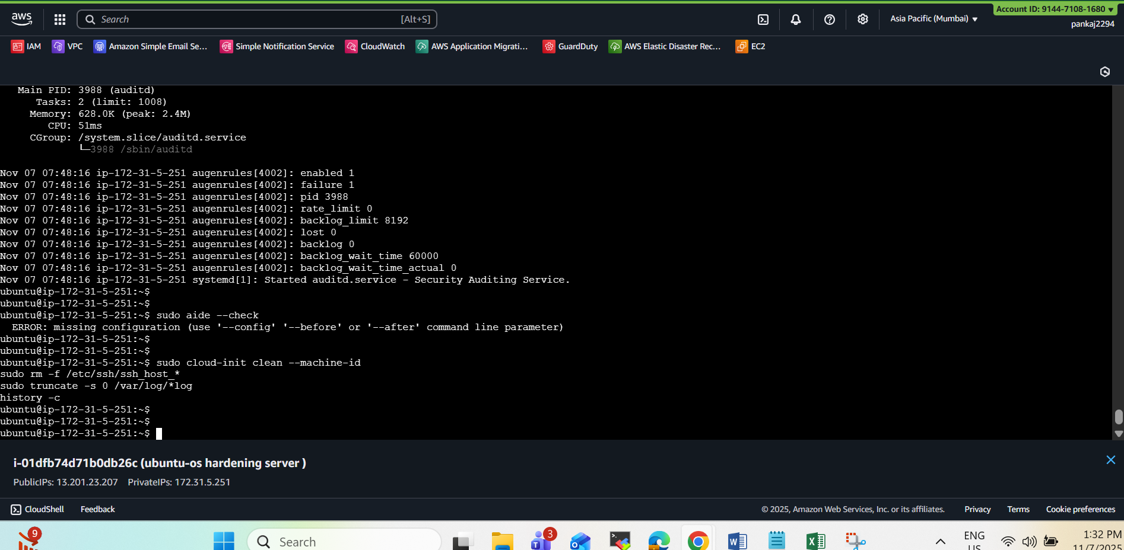

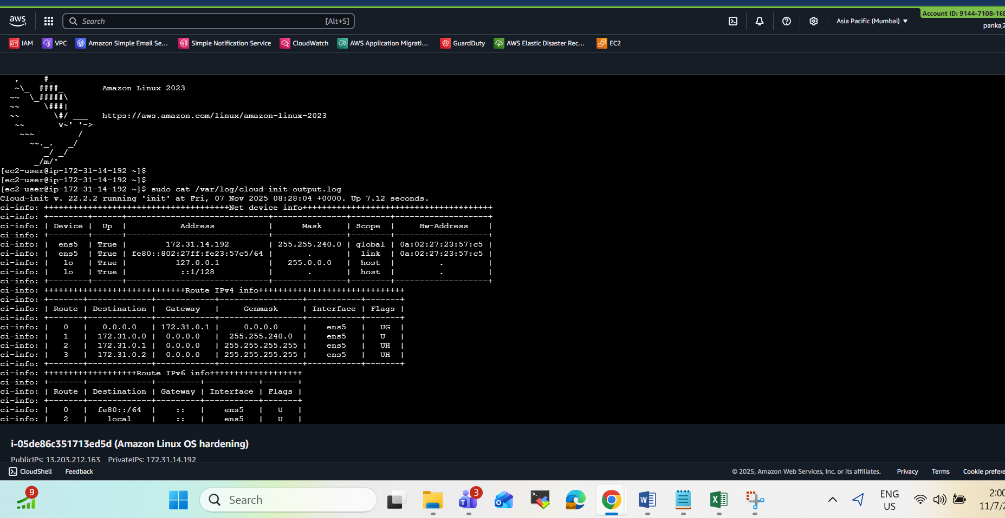
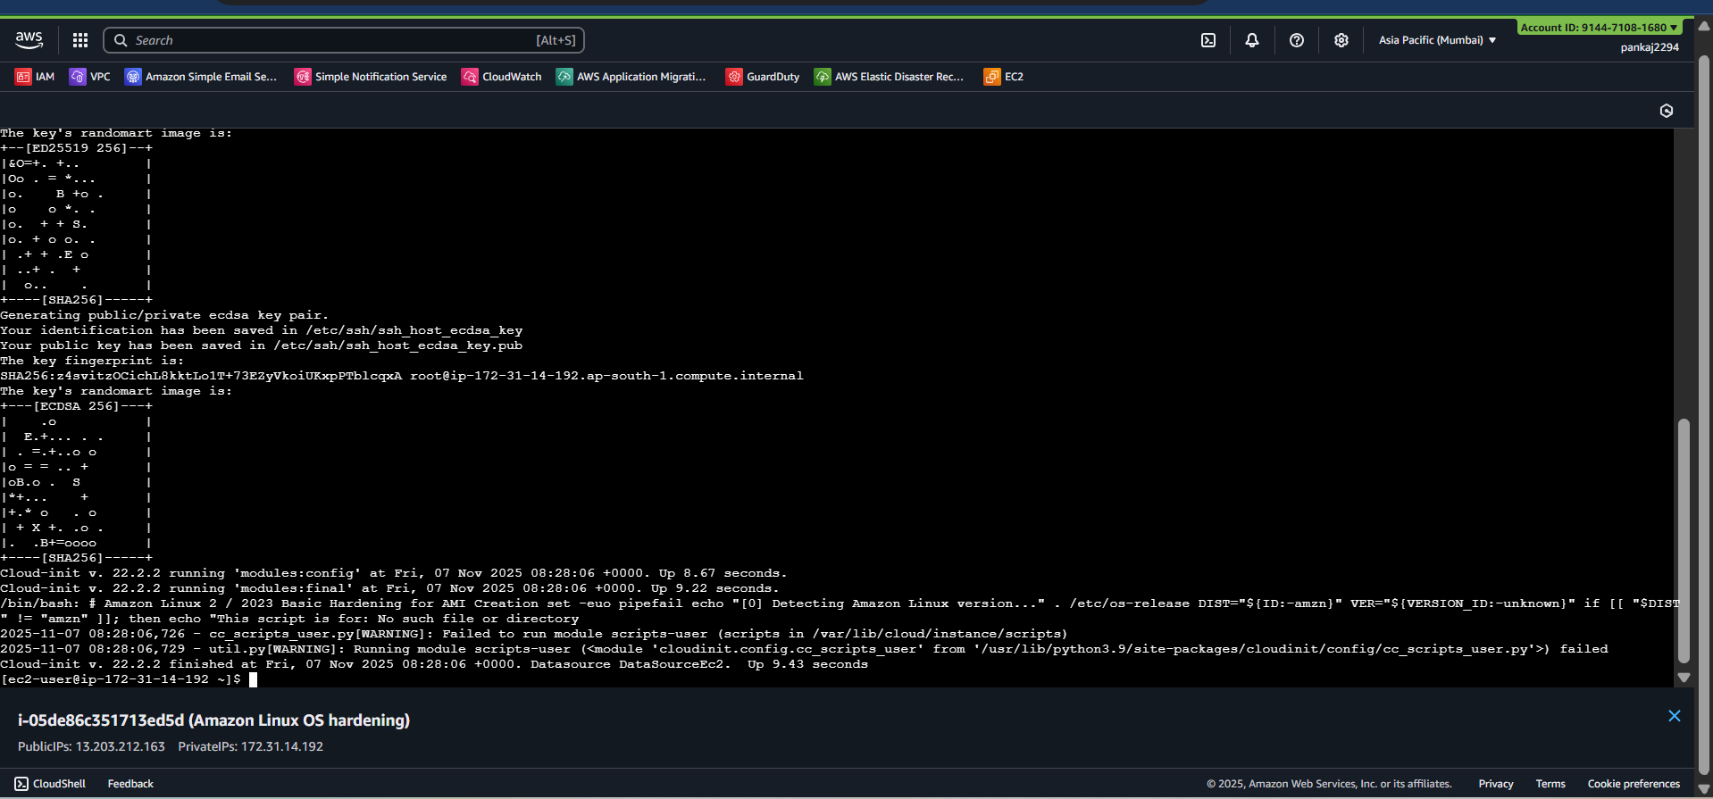
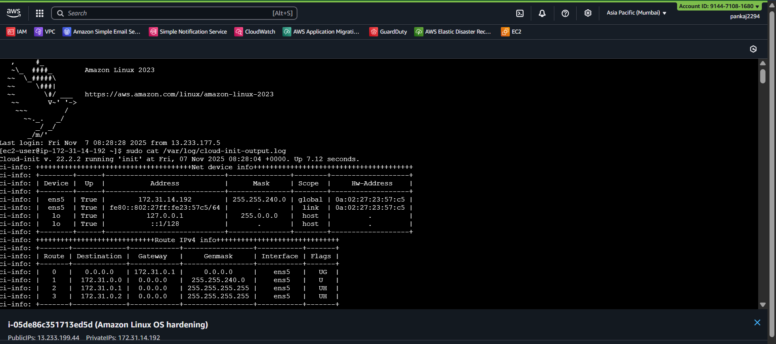
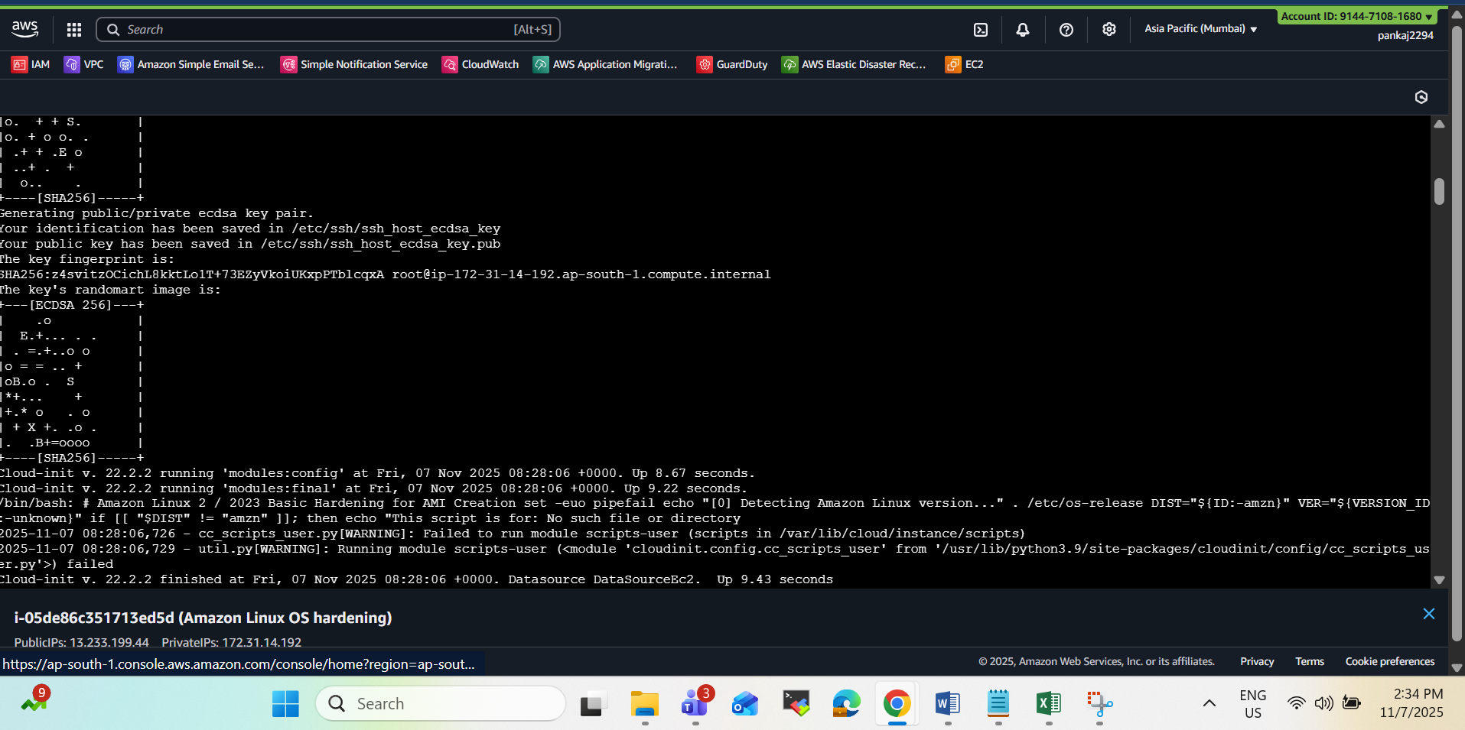
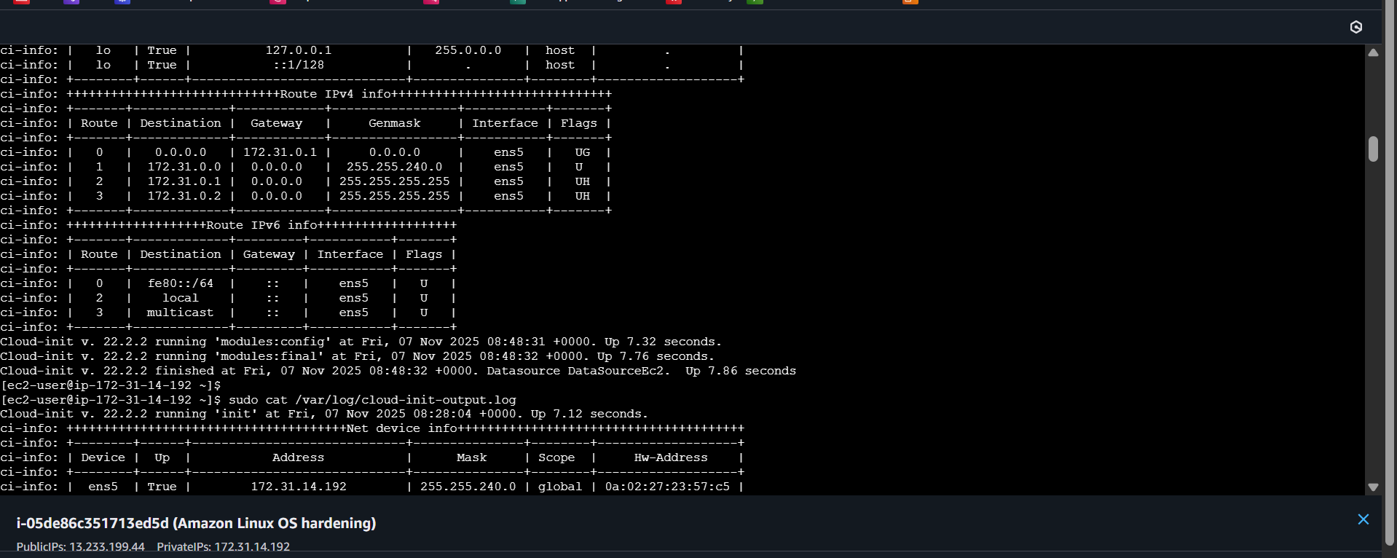
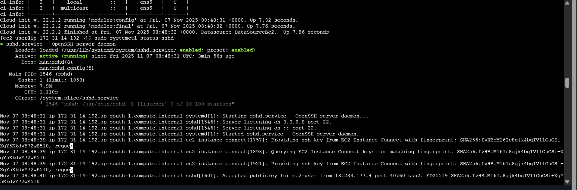
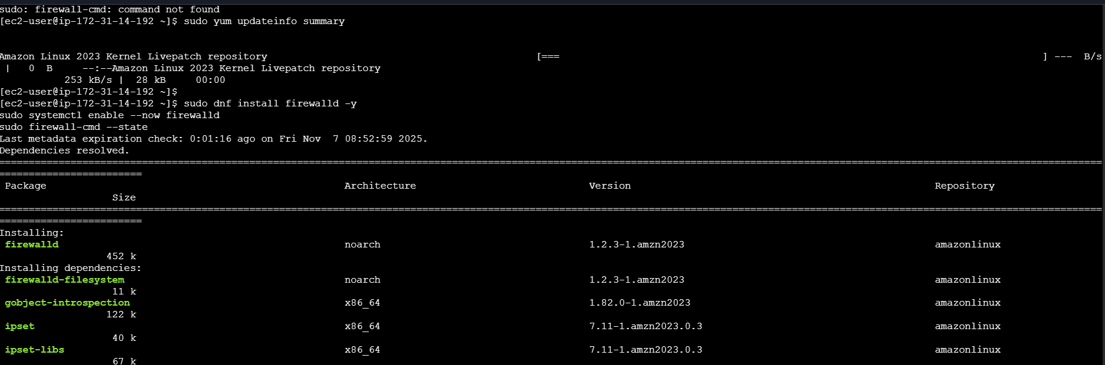
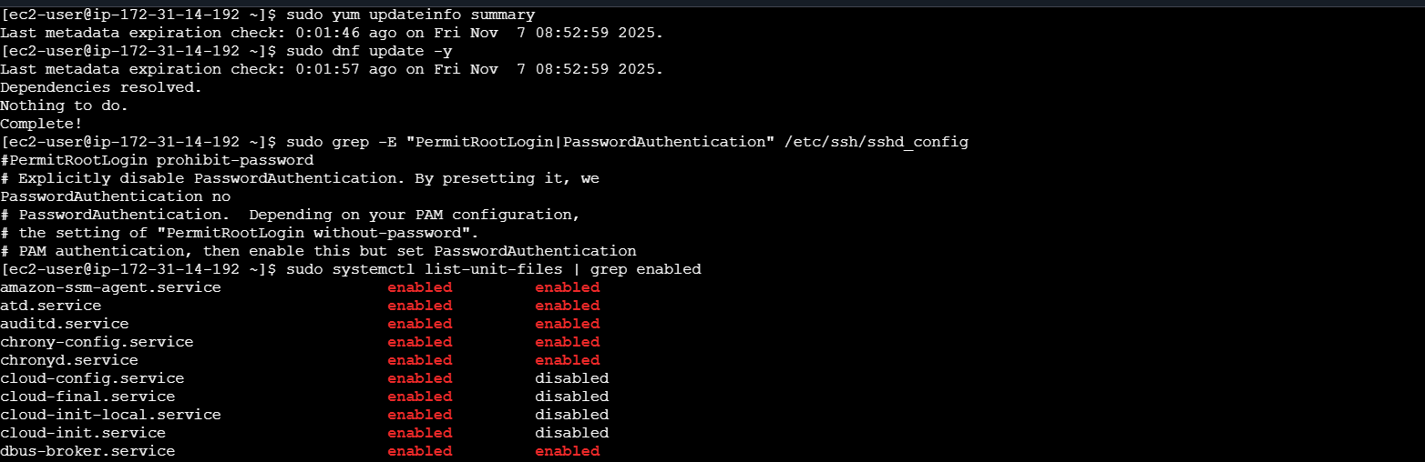

# | Category | Verification Command | Expected / Secure Output | Remarks
1️⃣ | Cloud-init Confirmation | sudo less /var/log/cloud-init-output.log | Script logs showing update, SSH, audit, AIDE, etc. steps executed | Confirms User Data executed successfully
2️⃣ | System Update Status | sudo dnf updateinfo summary | Lists available security updates (should be minimal after patch) | Confirms latest packages applied
3️⃣ | SSH Service Status | sudo systemctl status sshd | active (running) | Confirms SSH service operational
4️⃣ | SSH Configuration Hardening | `sudo grep -E "PermitRootLogin | PasswordAuthentication | MaxAuthTries
5️⃣ | Root Account Locked | sudo passwd -S root | root L (L = locked) | Prevents direct root login
6️⃣ | Firewall Installation | sudo systemctl status firewalld | active (running) (if installed manually) | Optional — AWS SGs act as main firewall
7️⃣ | Firewall Rules | sudo firewall-cmd --list-all | services: ssh (and optionally http/https) | Ensures only required ports open
8️⃣ | Auditd Service | sudo systemctl status auditd | active (running) | Confirms audit logging active
9️⃣ | AIDE File Integrity | sudo ls -l /var/lib/aide/aide.db.gz | File exists | Confirms AIDE database initialized
🔟 | Unnecessary Services Disabled | `sudo systemctl list-unit-files | grep enabled` | Should not include: cups, avahi-daemon, rpcbind
11️⃣ | CloudWatch Agent Installed | systemctl status amazon-cloudwatch-agent | active (running) | Confirms CloudWatch agent deployed
12️⃣ | SSM Agent Enabled | systemctl status amazon-ssm-agent | active (running) | Confirms EC2 SSM control via AWS Console
13️⃣ | /tmp Hardening | grep '/tmp' /etc/fstab | tmpfs /tmp tmpfs defaults,noexec,nosuid 0 0 | Ensures /tmp mounted securely
14️⃣ | Login Policy Check | sudo grep PASS /etc/login.defs | PASS_MAX_DAYS 90 etc. | Confirms password aging and warnings
15️⃣ | Logs Cleared for AMI | sudo ls -l /var/log/ | Log files truncated (if preparing AMI) | For golden image preparation only
